Particulate matter: an update of the PM10 levels in The Netherlands
Draft November 2006
Ronald Hoogerbrugge National Institute for Public Health and the Environment (RIVM)
P.O. Box 1 3720 BA Bilthoven, The Netherlands
Ronald.hoogerbrugge@rivm.nl

In 2005 the Netherlands Environmental Assessment Agency (MNP) and the National Institute for Public Health and the Environment published a comprehensive overview on the Dutch state of affairs on the particulate matter http://www.rivm.nl/bibliotheek/rapporten/500037011.pdf
This paper presents an update of the chapter 4 concerning the measurement data of particulate matter. References can be found in the overview.

Summary
The measured concentrations of particulate matter in the Netherlands are presented with exceedences of the two European limit values and the relationship between these limit values. In addition information about the infrastructure used for measurements, about the measurements themselves and about the measured components of particulate matter is given.
• The measured annual average concentration of particulate matter decreased with approximately 1 µg/m³ /year.
• In the Netherlands, the limit value for the annual average concentration and that for the 24-hour average are both being exceeded. Measurements show that the limit value for the 24-hour average is exceeded more often than that of the annual average concentration. The limit value for the 24-hour average therefore appears to be more stringent than the limit value for the annual average concentration.
• Particulate matter concentrations are measured in the Netherlands according to a methodology prescribed in European legislation. Measurements of PM10 are conducted in the Netherlands at 39 locations; 22 of these locations are in urban surroundings.
• Components of particulate matter are: inorganic secondary components, components that contain carbon, sea salt, oxides of metals and silicon and water. Sea salt and soil dust are important components of particulate matter; on an annual average basis, they amount to 20% to 30% of total particulate matter.
• Meteorological influences can lead to fluctuations in the annual average particulate matter concentration of around 5 µg/m³.
• Subtracting the contribution of sea-salt aerosol from the total particulate matter concentration has little effect on how often the limit value for the 24-hour concentration is exceeded. On average for the Netherlands, it is estimated that subtracting sea-salt aerosol results in six fewer days when the limit value for the 24-hour average is exceeded.

Concentrations in the Netherlands
The air quality regarding particulate matter in the Netherlands has improved during the past decade. The annual average concentrations have declined by 25% in ten years. During the same period, the number of days with a 24-hour average concentration above 50 µg/m³ declined by 50%. Nevertheless, both limit values are still exceeded in the Netherlands. It appears that the limit value for the 24-hour average is exceeded more often than the limit value for the annual average concentration (Figures 1-4).
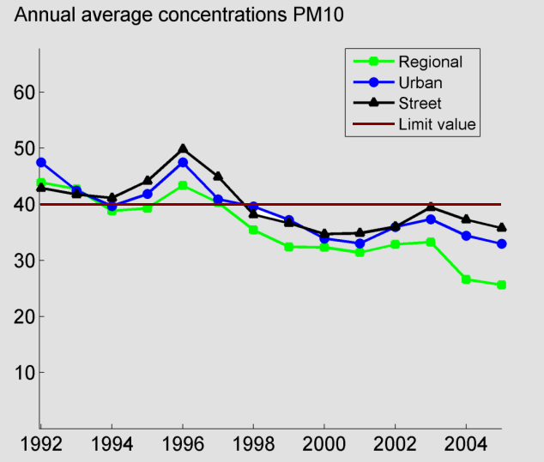
Figure 1 Measured annual average particulate matter concentrations in the Netherlands from 1992- 2005. The trend lines indicate the average of the stations in the corresponding group.

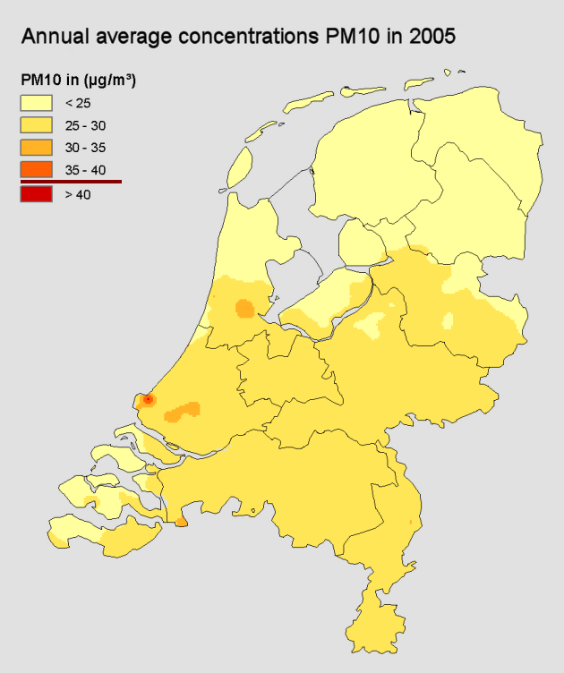
Figure 2 Annual average concentration of PM10 in 2005. The map for the annual average concentrations was obtained from measurement results from the Dutch National Air Quality Monitoring Network combined with model calculations.

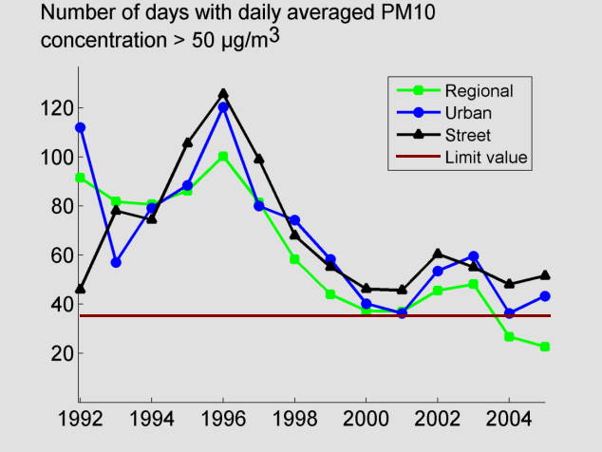
Figure 3 The number of days with a 24-hour average above 50 mg/m3 in the Netherlands in
2005 at measurement stations.

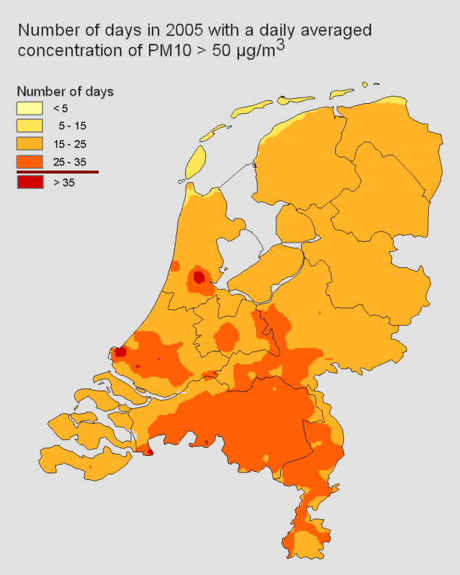
Figure 4 The map for the number of days where the limit value was exceeded. The plot is based upon the relation between annual average concentration and the number of days with a daily average > 50 µm/m³. The compliance problems concerning the limit value for the 24-hour average are concentrated on some spots/cities.

The measurement results for particulate matter also show the relationship between the two European limit values: the limit value for the annual average concentration, 40 µg/m³, and the limit value for the 24-hour average; the latter is a maximum of 35 days per year with a 24-hour average concentration above 50 µg/m³ (Figure 4.3). This relationship shows that the limit value for the 24-hour average corresponds with an annual average particulate matter concentration of approximately 31 µg/m³. The limit value for the 24-hour average is therefore significantly more stringent than the limit value for the annual average concentration.

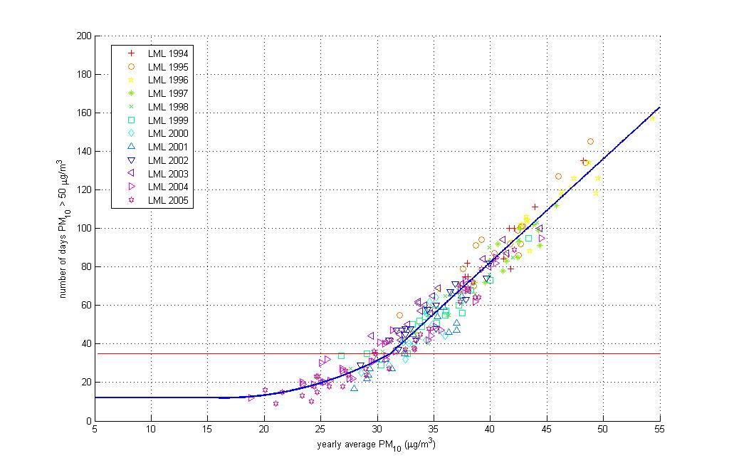

Figure 5 Relationship between the annual average particulate matter concentration and the number of days with a 24-hour average above 50 µg/m³. In the linear part of the relationship, high concentrations, every additional microgram of particulate matter results in five more days that exceed the limit value for the 24-hour average concentration. According to this relationship, an annual average concentration of 31 µg/m³, corresponds to 35 days with a 24-hour average concentration of 50 µg/m³.

Trends in the concentration
Figure 6 shows the trend in the annual average particulate matter concentration at the regional stations of the Dutch National Air Quality Monitoring Network. Assuming a linear relation the figure shows an approximated yearly decreasement of 1 µg/m3. The figure shows variations of the annual average particulate matter concentration up to 5 µg/m3 which is most likely due to variation in meteorological conditions.
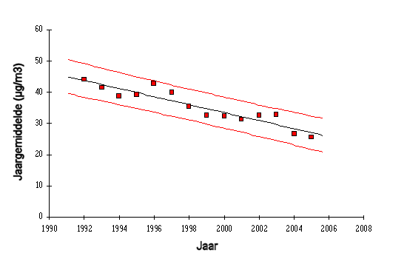
Figure 6 Measured trend in the annual average particulate matter concentration at the regional stations of the Dutch National Air Quality Monitoring Network. The figure shows variations of the annual average particulate matter concentration up to 5 µg/m³ (95 % confidence interval).

Monitoring infrastructure
The monitoring of particulate matter concentrations takes place in the Netherlands according to a methodology prescribed in European legislation. This monitoring has taken place in the Netherlands since 1992 (Van Elzakker, 2001). Initially, there were 19 monitoring stations in the monitoring network for particulate matter in the Netherlands. The Netherlands has chosen the numbers of monitoring stations in such a way that it is possible on the basis of the measurement results alone – therefore without the use of models – to provide a representative picture of the air quality for particulate matter in the Netherlands.

On November 2006, there were 16 regional stations, 8 urban background stations and 15 street stations in the monitoring network for particulate matter. One more street stations is planned this year. This will bring the total number of monitoring stations for particulate matter up to the intended number of 40. In 2005 only two exceedences of the annual average concentration were found. Both are street stations. Exceedences of the number of days above 50 µg/m3 were observered in 2005 at approximately 10 % of regional stations; 50 % of the urban background stations and 80 % of the street stations.

In the Netherlands, there are also a number of regional and local authorities which monitor particulate matter. The provinces of Limburg and North Holland have monitoring networks with two and six monitoring stations, respectively. The monitoring network of the DCMR Environmental Protection Agency in the Rotterdam region, has three monitoring stations, and the monitoring network of the GGD, Municipal Health Centre, in Amsterdam comprises five monitoring stations.

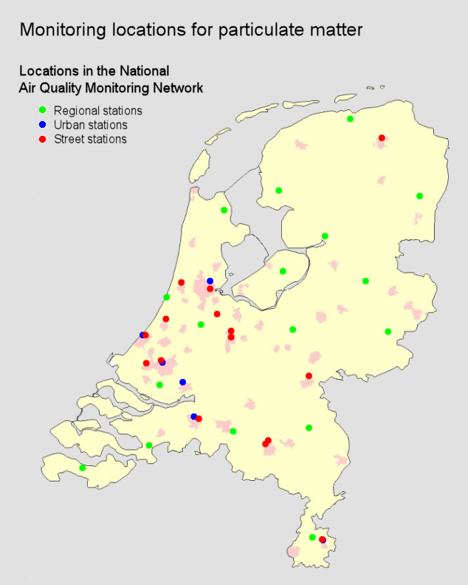
Figure 7 Monitoring locations for particulate matter (PM10) in the Dutch National Air Quality Monitoring Network 2006. Local monitoring networks for particulate matter are not shown.

Measurement method
The particulate matter measurements are conducted in the Netherlands with automatic monitoring apparatus that works according to the principle of the attenuation of beta radiation. A widely-used term for a device of this type is a beta attenuation analyzer. The results are multiplied with a correction factor to comply with the EU reference method. Until 2005 a correction factor of 1.33 is used on the measurement results of the beta attenuation monitors in the Dutch National Air Quality Monitoring Network. In the beginning of 2006 all measurement results were revalidated. In this revalidation the concentrations of PM10 are expressed on the basis on ambient temperature and pressure (used to be standard conditions). Also the EU default correction factor of 1.3 is used since the number of comparison measurements with the EU reference method was too limited for a high quality assessment.
The number of comparison measurements is increasing rapidly which might justify the assessment of a more specific correction factor shortly. Such an assessment will of course influence the results shown in this paper. The comparison measurements indicate that a measurement uncertainty within 25 % can be achieved.
Before 1992, particulate air pollution was monitored in the Netherlands only in the form of black smoke (Van Elzakker, 2001). However, black smoke is only a portion of particulate matter (and PM2.5). Therefore, statements about a possible trend in particulate matter concentrations can only be made on the basis of data from 1992 onwards.

Components of particulate matter
The measurement of particulate matter with the beta attenuation method is given in terms of mass per unit volume. It does not provide any information about the chemical composition of the particulate matter. Research has shown that the most important components of particulate matter are inorganic secondary components, carbon containing components, sea salt, oxides of metals and silicon and water (Visser et al., 2001; see chapter on Chemical composition of particulate matter in the Netherlands for a more extensive explanation). Sea salt and soil dust are important components of particulate matter: on a yearly average, they amount to 20% to 30% of total particulate matter. Between 25% and 50% of the sea salt aerosol is composed of particles in the PM2.5 fraction (Visser et al., 2001). Sea salt and the natural component of soil dust cannot be influenced by policy measures. Moreover, it is very probable that sea salt does not have any health effects. In current European legislation for particulate matter, however, the total concentration, therefore including fractions of natural origin, is regulated. As a result, a discussion is now taking place in the Clean Air for Europe (CAFE) programme about the possibility of making a statutory exception for components in particulate matter of natural origin which are also viewed as non-hazardous. An important question is: what is the relationship between the concentrations of sea salt and soil dust on the one hand and non-compliance with the limit values on the other? To answer this question, an initial estimate of the long-term average contribution of sea-salt aerosol to the particulate matter concentration in the Netherlands was made. This contribution was estimated at 4 - 5 µg/m³. Measurements have shown that the annual average sea-salt aerosol concentration on the coast is between 5 and 8 µg/m³; in the southern province of Limburg and on the eastern border of the Netherlands, this value is 3 µg/m3 (Figure 8; Visser et al., 2001; Denier van der Gon et al., 2003). Measurements of sea salt aerosol in the German federal state of Nordrhein- Westfalen indicate an average concentration of 1 to 2 µg/m³. These figures support the assumed distribution across the Netherlands.

Tentative estimates indicate that subtracting the contribution of sea-salt aerosol would bring the particulate matter concentration below the limit value for the annual average concentration of 40 µg/m³ (under average meteorological conditions). It is expected that this limit value would then only be exceeded locally, due to local traffic contributions. Non-compliance with the limit value for the 24-hour average is the most acute problem concerning the air quality regulations for particulate matter. However, the subtracting of the contribution of the sea-salt aerosol will have little effect on bringing the Netherlands into compliance with the limit value for the 24-hour average. This is because high particulate matter concentrations generally occur due to air movement from continental Europe. Under such conditions, the share of sea-salt aerosol in the particulate matter concentration is quite small (Matthijsen, 2005; Denier van der Gon and Schaap, 2005). The relationship between exceeding the limit value for the 24-hour average particulate matter concentration and the concentration of sea-salt aerosol has been investigated based on several measurements. It is estimated that subtracting the sea-salt aerosol will lead, on average for the Netherlands, to six fewer days when the value for the 24- hour average is exceeded. This estimate has a 50% uncertainty.

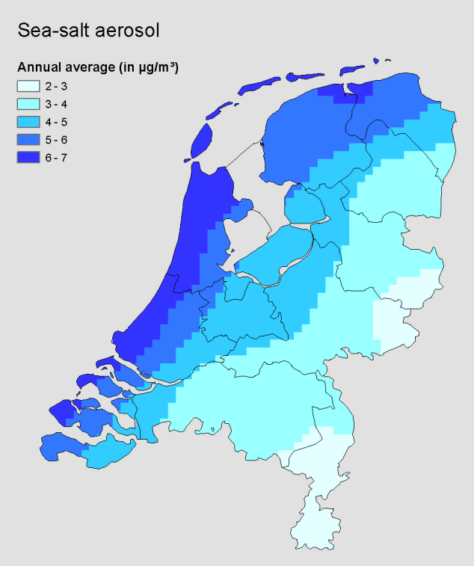
Figure 8 Annual average contribution of sea salt aerosol to the particulate matter concentration in the Netherlands. The estimate is based on interpolation of monitoring results and has been combined with assumptions about the distribution of sea salt along the Dutch coast (Eerens et al., 1998; Eerens, 1998).

Chemical composition of particulate matter in the Netherlands
Recent measurements of the chemical composition of particulate matter in the Netherlands have led to a good understanding of the average composition of particulate matter (Visser et al., 2001). The components are the following:
Inorganic secondary components. This primarily concerns sulphate (SO₄), nitrate (NO₃) and ammonium (NH₄) aerosol. These particles are formed in the atmosphere from the gases sulphur dioxide (SO₂), nitrogen oxides (NO_{x}) and ammonium (NH₃). The contributions in terms of mass of these components to the annual average concentration is around 10 µg/m³. Approximately 90% of these components are found in the PM2.5 fraction. Virtually all these secondary components are of anthropogenic origin.
Carbon-containing components. This primarily concerns elementary carbon and organic compounds. The majority of these compounds are emitted directly into the atmosphere. The contribution in terms of mass of these components is 5 µg/m³, of which 1 µg/m³ is elementary carbon and 4 µg/m³ comprises organic compounds. Soot is composed of a mixture of elementary carbon and organically bound carbon. A small portion of the carbon-containing components is formed in the air by a chemical reaction; this is the secondary organic aerosol. Of the carbon-containing components, 90% are found in the PM2.5 fraction. This group also contains a very small (in terms of mass) quantity of polycyclic aromatic hydrocarbons (PAHs). The elementary carbon and the PAHs are entirely of anthropogenic origin, while the other organic compounds are partly of natural origin and partly of anthropogenic origin.
Sea salt. Sea salt is composed primarily of sodium chloride (table salt) with a smaller contribution from magnesium, calcium and potassium compounds. Sea-salt aerosol is of natural origin and is formed in the air when the wind blows over the sea’s surface. On average across the Netherlands, the contribution in terms of mass of sea salt is 4-5 µg/m³. Between 25% and 50% of the sea salt is found in the PM2.5 fraction.
Oxides of metals and silicon. This primarily concerns oxides of silicon, aluminium, calcium, iron and potassium. This can be largely attributed to windblown soil dust. This soil dust comes into the air primarily as the result of human activities. The total soil dust concentration is on the order of 4 µg/m³ on average across the Netherlands. Soil dust is largely comprised (70% to 90%) of particles larger than PM2.5.
Water. Components of particulate matter, especially inorganic secondary components, can contain chemically-bound water. The contribution of chemically-bound water is estimated at 10% to 15% of the total particulate matter concentration. The share of water in the PM2.5 fraction is larger because water is bound especially to inorganic secondary components.

See also contribution from Ernie Wijers and Saskia van der Zee on PM gradients in the Amsterdam area

