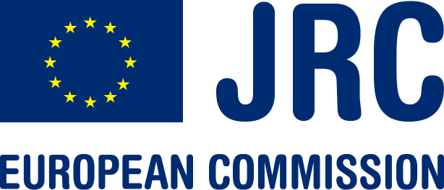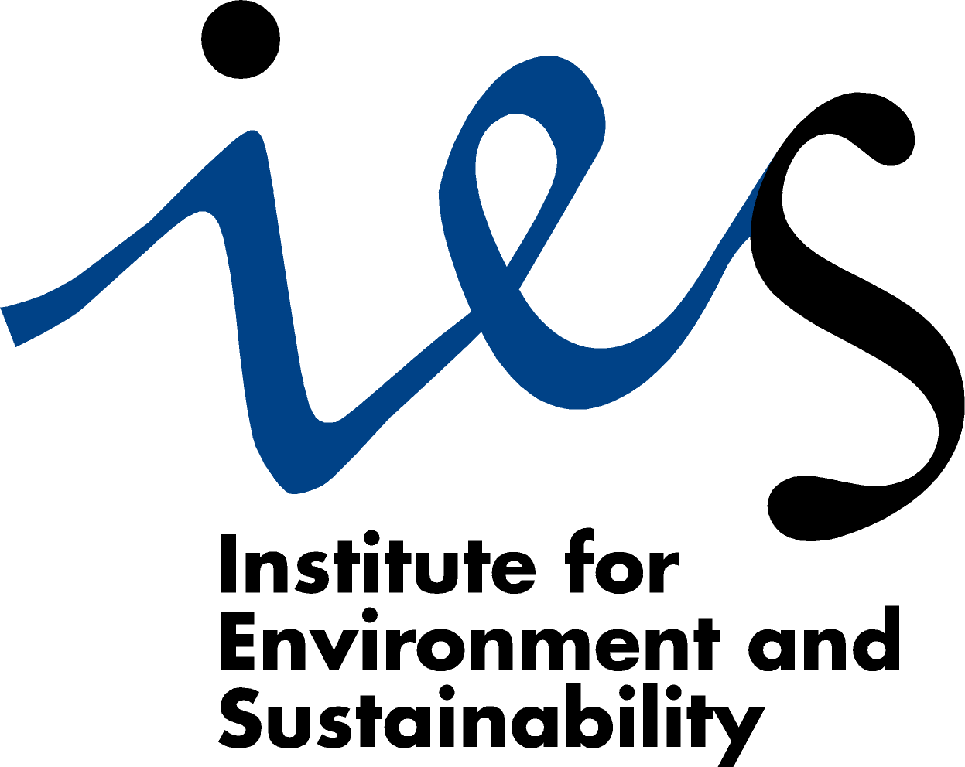

CONVENTION ON LONG-RANGE
TRANSBOUNDARY AIR POLLUTION

Task Force on Measurement and Modelling Workshop :

19-20 November 2009
Back-to back with the
FAIRMODE plenary meeting
18 November 2009

Ispra, Italy

Main items in the meeting agenda

Thursday, 19th November 2009

9:30 – 12:30 : Modelling activities of the TFMM

- Feedback from the FAIRMODE plenary session
- Contribution of the TFMM to FAIRMODE
- Contribution of the TFMM to EC4MACS
- EURODELTA follow-up: rationale, resources, project design.....
- Publication issues

14:00- 17:00 : Heavy metals test case study

- Presentation of the test case framework
- Feedback from the participants
- Future test case study : which compounds, where, data availability, time line, decisions
- Publication issues

Friday, 20th November 2009

9:30 – 12:30 : Future EMEP field campaigns

- Feedback from the previous field campaigns
- Country needs and priorities
- Modellers needs
- 2011 EMEP field campaign: which pollutants, where, coordination...
- Publication issues

12:30 – 13:00 : Conclusions

